

**Project Document**

**Name : Mellisaivani M**

**Register Number : 720722106023**

**Department : ECE**

**Year : II - YEAR**

**Project Title**

**Enhancing digital payment security and usability by design thinking**

**Template Name**

**Brainstorm and Idea Prioritisation**

**Problem Statement**

**Online digital payment experiences are marred by complex interfaces,security concerns,device compatability issues, and inadequate customer support. Enhancing security measures,ensuring cross device compatability and improving customer support are critical steps to streamline the payment process and boost user satisfaction.**

**Project description**

**Secure pay is a comprehensive project aimed at enhancing the security of digital payment systems through the application of innovative design principles. In collaboration with company experts and stakeholders,the project seeks to address the growing challenges by cyber security threats facing online transactions.By leveraging design thinking methodologies,the project will identify,prototype and implement cutting edge solutions to safeguard user data,authenticate transactions and mitigate the risks associated with digital payments.**

**Worked Template with explanation**

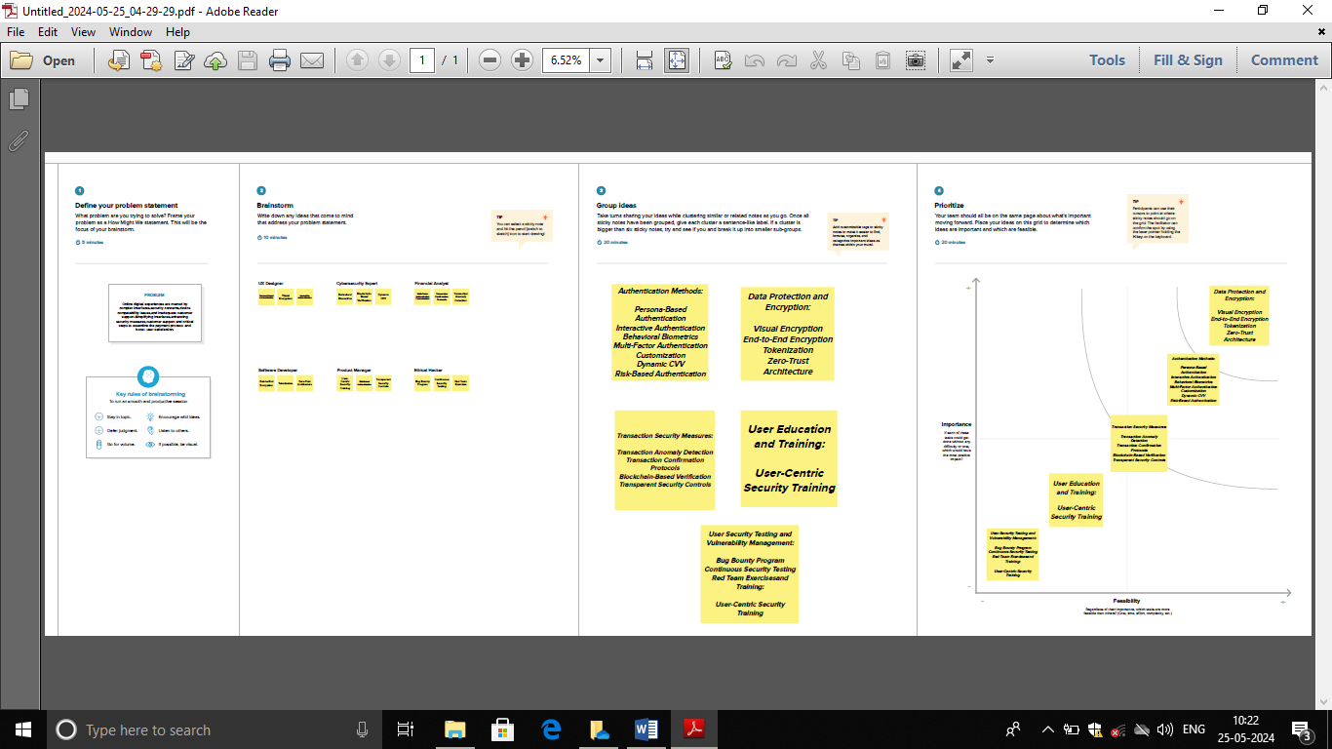

**Home**

**The main page where visitors get an overview of the company and access to different sections of the website.**

**About Us**

**Provides information about the company's mission, vision, team, and history to help visitors understand who they are and what they stand for.**

**Products/Services**

**Showcases the various products or services the company offers, categorized for easy navigation.**

**Blog/Resources**

**Contains articles, guides, and other valuable content that provides insights, tips, and information relevant to the company’s industry.**

**Customer Service**

**Offers contact options and support resources to assist customers with their inquiries and issues.**

**About Us**

**(Note: This is likely a duplication error in your list and should be merged with the initial "About Us" section.)**

**GitHub Link:**

[**https://github.com/vishnuvishnum1817/IBM.git**](https://github.com/vishnuvishnum1817/IBM.git)